REGISTRATION FORM OF 12th GCOET CONFERENCE 2023
14-15 September 2023
NOVOTEL BANGKOK PLATINUM PRATUNAM, BANGKOK, THAILAND
(IN-PERSON & ONLINE)
http://gcoet.org/pay.html

12th GCOET will be held during 14 - 15 September 2023 at Novotel Bangkok Platinum Pratunam, Bangkok, Thailand; please note that it is essential for all participants to email the filled Registration Form (.doc/.docx/pdf) along with Proof of payment receipt to ids: admin@gcoet.org and Cc to register@gatrenterprise.com

SECTION 1: CONTACT INFORMATION
Paper ID Code: For example, GCOET-00101
Name that you would like to get printed on the certificate:

Conference Title: 12th Global Conference on Engineering and Technology, Bangkok, Thailand.
Whether attend the Conference: € Yes € No
Position (Professor/Associate Prof/Assistant Professor/Lecturer/PhD Student/Master Student/other):

Full Affiliation/Organization/University and Country Name:
(That you like to get printed on the certificate)

Broad Field: i.e. Civil |  | Are you willing to serve as a session chair:(Yes (No
Session Type: € Oral Presenter € Participant (Without paper) € Visual Presenter
Telephone: | Mobile: |  |  | Email:
Special Needs or Dietary Requirements: € Yes € No
Student ID Number of Your University (if applicable):
Paper Title:
Paper Pages: |  | Additional Page:
Are you interested in joining Conference Tour: |  |  | € Yes € No
Are you interested in attending GALA Dinner & Networking: |  |  | € Yes € No
Are you interested in attending Workshop: |  |  | € Yes € No
Are you interested in joining Academic Discussion Session: |  |  | € Yes € No

Notes:
- One regular registration can cover a paper within 8 pages, including all figures, tables, and references at 1.5 line spacing. If the length exceeds 8 pages, the authors must pay a publication fee of USD 25.00 for each additional page.

- If a number of authors are more than two in the manuscript, authors must pay additional fees of USD 50 for each additional author name.

- For additional Certificates, co-authors must pay USD 100 for each additional certificate.

SECTION 2: REGISTRATION FEES INFORMATION

12TH GCOET FEE SCHEDULE: | Early bird  Until: 3/05/2023 | Normal  Until:  19/06/2023 | Late  Until: 06/09/2023
Oral/Poster Presenter (Lead Author) / Co-author | USD 225 | USD 275 | USD 300
Visual Presenter (Through ZOOM) | USD 125 | USD 175 | USD 175
Full-Time Student (Valid student ID required) | USD 150 | USD 175 | USD 200
Additional Paper (by the same Presenter) | USD 150 | USD 175 | USD 200
Attendee (Without abstract/Paper) | USD 125 | USD 175 | USD 175
Online Attendee (Without abstract/Paper) (Through ZOOM) | USD 100 | USD 100 | USD 100
Additional Events for 12th GCOET Delegates:
Academic Discussion Session on 14 September 2023 (IN-PERSON & ONLINE) | FREE | FREE | FREE
GALA Dinner & Networking on 14 September 2023 | FREE | FREE | FREE
Workshop on Publishing in High Impact Factor (ABS & ABCD) Indexed Journals on 15 September 2023 (IN-PERSON & ONLINE) | FREE | FREE | FREE

GATR/GCOET Policy:

- The lecturer cum student will not be considered for the student rate.
- A full-time student must submit a valid student ID card and letter of recommendation Dean/advisor.
- Daily Market Conversion Rate applies to all USD prices.
- Service/Transfer Fees are not included in the above prices.

Registration fee of Regular/Visual/Student Presenter Included:

- Academic Discussion Session
- Card holder, Printed name card
- Conference bag & Pen
- Printed presenter certificate
- Refereed Proceeding CD with ISBN
- Journal publication fees (Sponsored by GATR)
- Printed Program Schedule
- Two coffee breaks each day.
- International Buffet lunch daily
- GALA Dinner & Networking

Registration fee of Observer Included:

- Card holder, Printed name card
- Conference bag & Pen
- Printed Program Schedule
- Two coffee breaks each day.
- International Buffet lunch daily
- GALA Dinner & Networking

Registration fee of Attendee Included:

Admission to all session

- Participation Certificate with an official seal
- Refereed Proceeding CD with ISBN
- Program Schedule
- Workshop on Publishing in SSCI & SCI Journals Material & CD
- Best Presenter Certificate

SECTION 3: PAYMENT INFORMATION

Option 1

You can pay the registration fee by Bank Deposit/ATM Transfer/Online Transfer/ Telegraphic Transfer in Company’s official account.

Please Visit: http://goet.org/pay.html.
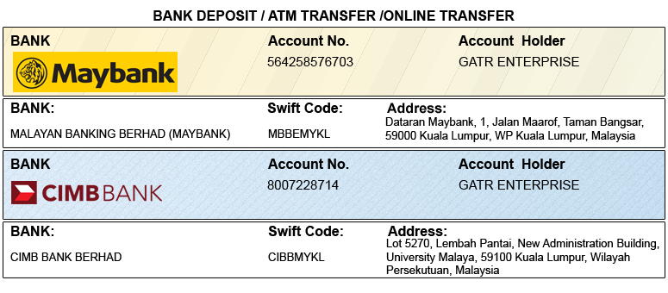

Option 2

You can pay the registration fee through 2checkout Credit Card /Debit Card/PayPal in Company’s official account.

Please visit: http://gcoet.org/pay.html

PRIVACY POLICY:

The Global Academy of Training & Research (GATR) Division will protect your personal information. Your personal information received will only be used to fill your order. We will not sell or redistribute your information to anyone.

CANCELLATION POLICY:

You may cancel without penalty if the written cancellation request is received up to and including 45 days before the start of the conference. A credit voucher for less than 50% of the registration fee will be issued for written requests received up to and including 25 days before the start of the conference. No refunds or credits will be issued on cancellation requests received less than 25 days before the start of the event. Global Conference on Engineering and Technology assumes no liability for the program, date, content, speakers, or venue changes.

PLEASE NOTE: Original receipts will be emailed to register guests before the conference for claim purposes.

Declaration: I agree that I cannot claim back the registration fee I paid under any circumstance.
SIGNED:  (or write your name here) |  | DATE:

